**Week 19 Stacks**

**Stacks**

* Elements are sorted by insertion order.
* Last element in is first out
* Elements have no index
* Can only add to top and remove from top

Push/pushed - add pop/popped - removed

**Queue**

* Elements are sorted by insertion order
* First element in is first out
* Elements have no index
* Can only add to back and remove from front

Enqueue – add Dequeue – remove

**Stack**

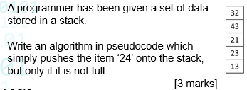

Stack = [ 13, 23, 21, 43, 32]

IF top_pointer == LenArray THEN

OUTPUT (“Stack is full”)

ELSE:

Stack(top_pointer + 1) = 24

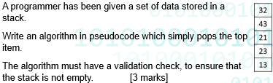

Stack = [ 13, 23, 21, 43, 32]

IF top_pointer == 0 THEN

OUPUT (“Stack is empty”)

ELSE:

Item = stack(top_pointer).pop

top_pointer = top_pointer – 1

**QUEUE**

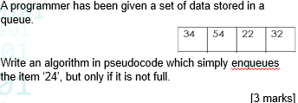

Queue = [34, 54, 22, 32]

IF front_pointer == (rear_pointer + 1) THEN

OUTPUT (“Queue is full”)

ELSE:

Queue(rear_pointer + 1) = 24

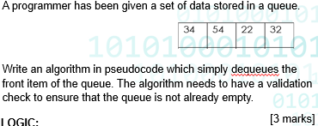

Queue = [34,54,22,32]

IF front_pointer == rear_pointer THEN

OUTPUT (“Queue is empty”)

ELSE:

Item = queue (front_pointer)

Front_pointer = front_pointer + 1